Class: SYMCA Div: B  Semester: III | Course Code: MCA01605  Course Name: Web Programming Laboratory |  | Batch: S1
Name: Tejashree Vijay Dumasia |  | Roll No: 52117
CO No: CO606.3 |  | Assignment No: 08
PRACTICAL SUBMISSION RECORD- A.Y. 2024-25

Title: Create an application for Students Record using AngularJS.

Code:

<!DOCTYPE html>
<html lang="en" ng-app="studentApp">
<head>
<meta charset="UTF-8">
<title>Students Record - AngularJS</title>
<script src="https://ajax.googleapis.com/ajax/libs/angularjs/1.8.2/angular.min.js"></script>
<style>
h2 {
font-weight: 500;
margin-bottom: 16px;
}
form {
display: flex;
gap: 8px;
margin-bottom: 20px;
}
input {
border: 1px solid #ddd;
border-radius: 4px;
padding: 6px 10px;
font-size: 15px;
background: #fff;
outline: none;
}
button {
background: #222;
color: #fff;
border: none;
border-radius: 4px;
padding: 6px 16px;
font-size: 15px;
cursor: pointer;
transition: background 0.2s;
margin-right: auto;
}
table {
width: 100%;
border-collapse: collapse;
background: #fff;
box-shadow: 0 1px 4px rgba(0,0,0,0.03);
}
th, td {
padding: 10px 8px;
text-align: left;
}
th {
border-bottom: 1px solid #eee;
font-weight: 500;
background: #f8f9fa;
}
tr[ng-if] td {
text-align: center;
color: #aaa;
}
</style>
</head>
<body ng-controller="StudentController">
<h2>Students Record Application</h2>
<form ng-submit="addStudent()">
<input type="text" ng-model="newStudent.name" placeholder="Name" required>
<input type="number" ng-model="newStudent.roll" placeholder="Roll No" required>
<input type="text" ng-model="newStudent.course" placeholder="Course" required>
<button type="submit">Add</button>
</form>
<table>
<tr>
<th>#</th>
<th>Name</th>
<th>Roll No</th>
<th>Course</th>
<th>Action</th>
</tr>
<tr ng-repeat="student in students">
<td>{{$index + 1}}</td>
<td>{{student.name}}</td>
<td>{{student.roll}}</td>
<td>{{student.course}}</td>
<td>
<button ng-click="removeStudent($index)">Delete</button>
</td>
</tr>
<tr ng-if="students.length === 0">
<td colspan="5">No records found.</td>
</tr>
</table>
<script>
angular.module('studentApp', [])
.controller('StudentController', function($scope) {
$scope.students = [
{ name: 'Tejashree', roll: 1, course: 'MCA' },
{ name: 'Aadesh', roll: 2, course: 'MCA' }
];
$scope.newStudent = {};

$scope.addStudent = function() {
if ($scope.newStudent.name && $scope.newStudent.roll && $scope.newStudent.course) {
$scope.students.push(angular.copy($scope.newStudent));
$scope.newStudent = {};
}
};

$scope.removeStudent = function(index) {
$scope.students.splice(index, 1);
};
});
</script>
</body>
</html>
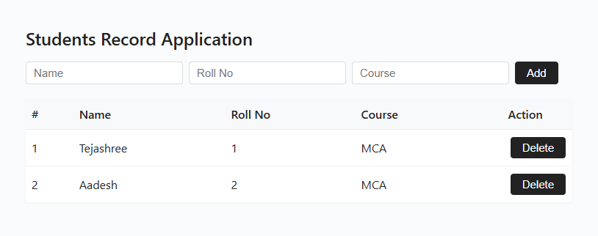
Output:

